Colonial Era 1.1

SSUSH1 Compare and contrast the development of English settlement and colonization during the 17th Century.
a. Investigate how mercantilism and trans-Atlantic trade led to development of colonies.
Document Analysis 1
Mercantilism and Trans-Atlantic Trade
The founders of the British colonies were greatly influenced by an economic theory known as mercantilism. This theory held that Earth had a limited supply of wealth in the form of natural resources, especially gold and silver, so the best way to become a stronger nation was to acquire the most wealth. Because the world's wealth was thought to be limited, the more one country had, the less any other country could have. Consequently, as a nation became stronger and wealthier, its enemies became poorer and weaker.
Mercantilism inspired the British government to view its American colonies as sources of wealth that would make Britain wealthier and stronger. The more land the British could colonize in America, the less land in the New World there would be available to France and other European countries. The more American goods the British could sell to other countries, the less money those countries would have for themselves. Great Britain would get greater, and its European rivals would get weaker.
Mercantilism also inspired Parliament to control trans-Atlantic trade with its American colonies. All goods shipped to or from British North America had to travel in British ships, and any goods exported to Europe had to land first in Britain to pay British taxes. Some goods could be exported to Britain only. These restrictions were designed to keep the colonies from competing against Britain. Some Americans responded by becoming smugglers.
Document Analysis 2

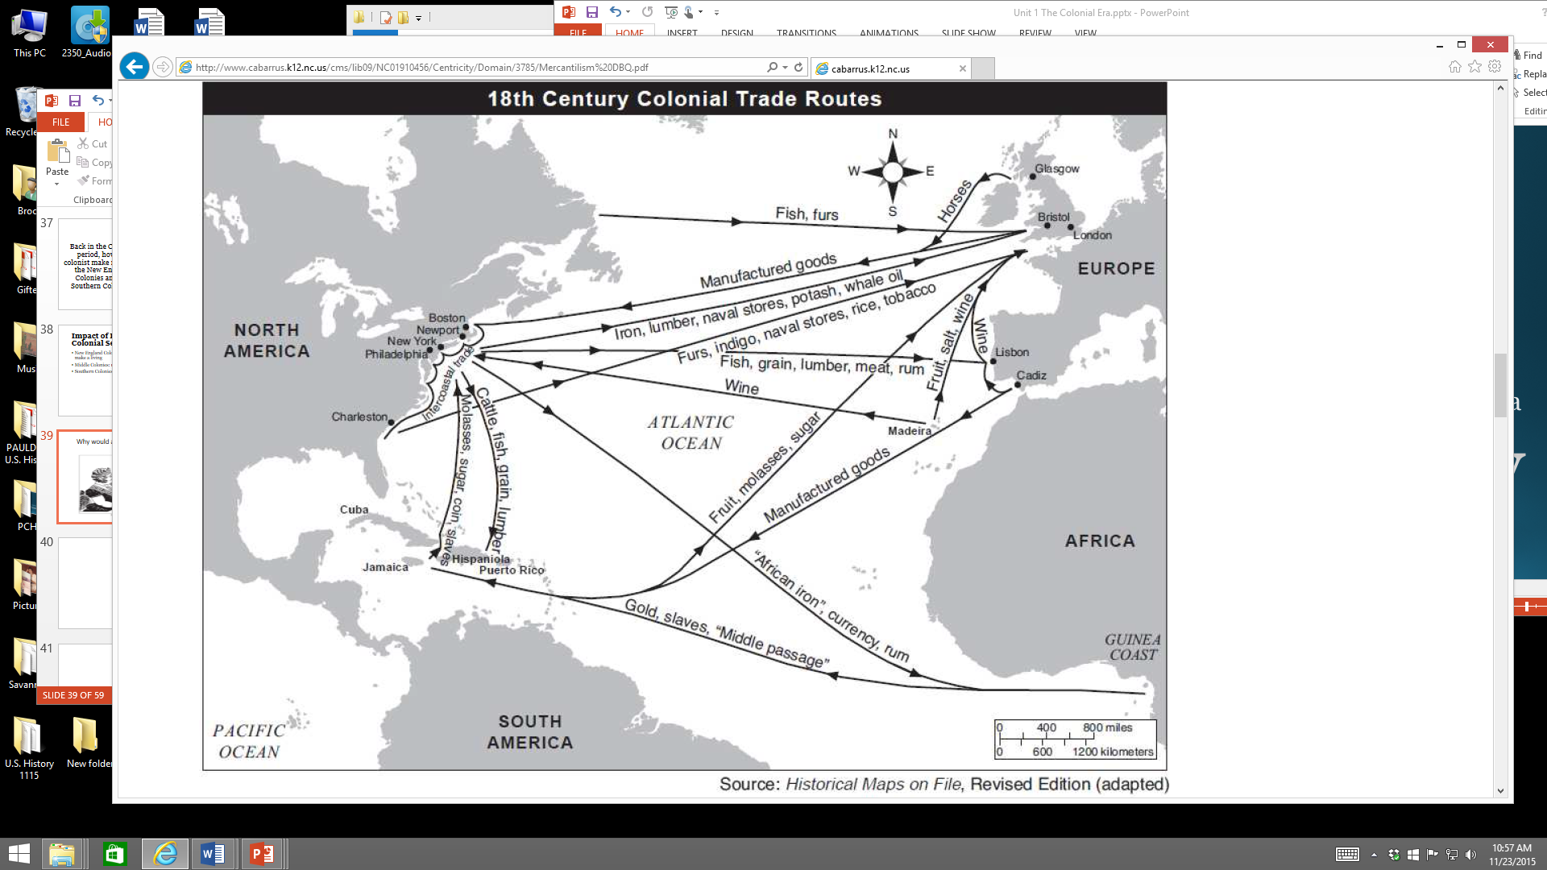
b. Explain the development of the Southern Colonies including but not limited to reasons established, impact of location and place, relations with American Indians, and economic development.
Development of the Southern Colonies
The Southern Colonies included Virginia, Maryland, Carolina (which eventually split into North Carolina and South Carolina), and Georgia. The location of the Southern Colonies, with the region’s rich soil and long growing season, fostered the development of strong agricultural producing colonies. Deep rivers and the distance of the fall line from the coast meant that inland farmers were able to ship tobacco, indigo, corn, and rice directly from their farms to European markets. The economic development of the Southern Colonies reflected this geological line. Subsistence family farms tended to develop north of the fall line. These farms grew primarily what the family needed along with a small cash crop used to purchase or barter for goods such as salt, gunpowder, lead, and iron tools.
Commercial farms tended to develop south of the fall line and grew primarily high yield, labor intensive cash crops such as rice, tobacco, and indigo. As a result, slave labor was more common south of the fall line while less common north of the same line. Relations with American Indians in the Southern Colonies began somewhat as a peaceful coexistence. As more English colonists began to arrive and encroach further into native lands, the relationship became more violent. The complexity of the interactions with American Indians in the Southern Colonies grew as the region’s economic development grew. Once large scale cash crops of tobacco, rice, and indigo proved highly profitable in the mercantilist system, more colonists arrived seeking economic opportunity. The growing English population in the Southern Colonies required more of the American Indians’ land for crop cultivation, which fueled increased tension between the groups.

c. Explain the development of the New England Colonies including but not limited to reasons established, impact of location and place, relations with American Indians, and economic development.
Development of the New England Colonies
The New England Colonies (Massachusetts, Rhode Island, Connecticut, and New Hampshire) were marked by poor, thin, rocky soils and a relatively short growing season that made farming difficult. However, plentiful forests and proximity to the sea led New Englanders to eventually develop a thriving ship building industry. Fishing, whaling, and commercial trade from harbors such as Boston became important economic engines for the region. New Englanders became the merchants of the colonies and New England-based ships were the carriers of colonial goods in the trans-Atlantic trade.
Whereas England’s Southern Colonies were developed for primarily economic gain, the New England Colonies developed initially as religious outposts by various subjugated groups. In particular, Calvinists in England faced increased persecution for their desire to reform the Anglican Church (also known as the Church of England) and their opposition to the growing power of the English monarchy. These religious dissenters, known as Puritans, disagreed with the Protestant Anglican Church’s continued use of Catholic rituals and traditions. The Puritans wanted to “purify” their Protestant sect of its heavily entrenched Catholic features. Although the Puritans came to North America for religious reasons, they were not religiously tolerant of those who did not fully comply with their views of religion.
American Indians were viewed by the Puritans as needing to be saved from their sinful ways since they were not Christians. In the early years of English colonization, the relationship between the American Indians and the Puritans was based primarily on trade and diplomacy given that the Englishmen were greatly outnumbered. The Puritans did not openly embrace the American Indians but relied on them for help in the difficult early years for survival. As the English population increased, so did the conflict with natives of the area. A series of bloody wars (King Philip’s War and the Pequot Wars) ensued during the colonial period between the Puritans and the American Indians of New England.
d. Explain the development of the Mid-Atlantic Colonies including but not limited to reasons established, impact of location and place, relations with American Indians, and economic development.
Development of the Mid-Atlantic Colonies
The Dutch established the North American colony of New Netherland in 1614. The colony, held by one of England’s European rivals, was founded as a private money-making venture by the Dutch. Trade was centered around New Netherland’s port of New Amsterdam (present day New York City). The Dutch colony’s location between England’s Southern and New England colonies in North America made it attractive for English annexation. England did seize control of New Netherland from the Dutch in 1664. New Netherland’s governor, Peter Stuyvesant, negotiated the colony’s transfer to English control without much resistance. The Mid-Atlantic colonial region is noted for its significant cultural and religious diversity due to its unique transition to England as an already established colony.
The English Mid-Atlantic Colonies (New York, New Jersey, Pennsylvania, and Delaware) that were created from the previous Dutch New Netherland colony were geographically fortunate to have good harbors and river systems that significantly shaped their development. The Hudson and Delaware Rivers provided highways to the interior of North America. Furs acquired from American Indians through trade for European goods, such as iron tools and firearms, were transported toward the coast along swift rivers. Later, the region’s farmers were able to use the rivers to ship wheat and other agricultural goods to markets in other colonies and Europe. The rivers also provided the colonists of the mid-Atlantic region with access to manufactured goods imported from European markets. Harbors in cities such as Philadelphia and New York City allowed the Mid-Atlantic Colonies to grow into major commercial hubs for all of England’s American colonies.
American Indians of two major language groups, Algonquian and Iroquois, resided in England’s Mid-Atlantic Colonies. The natives who resided there were typically relied upon for trade with the English and not the target of war, as was often the case in the other English colonial regions. Pennsylvania, in particular, treated the American Indians with more respect as evidenced by William Penn’s insistence on compensating the natives for their land.
The Mid-Atlantic Colonies geographic position united the American coast line under English control. Economically, the region’s colonies developed into strong merchant centers similar to their New England neighbors to the north. However, the Mid-Atlantic Colonies also farmed significant quantities of wheat and corn, similar to the cash crop production of their southern neighbors. The Mid-Atlantic Colonies were truly a bridge between the large scale farmers of the Southern Colonies and the merchants of the New England Colonies due to the geography and climate of the mid-Atlantic region.

