The Cold War 10.2

SSUSH20 Analyze the U.S. international and domestic policies including their influences on technological advancements and social changes during the Truman and Eisenhower administrations.
a. Analyze the international policies and actions developed as a response to the Cold War including containment, the Marshall Plan, the Truman Doctrine, and the Korean War.
Cold War
In 1945, one major war ended and another began. The Cold War lasted about 45 years. There were no direct military campaigns between the two main antagonists, the United States and the Soviet Union. Yet billions of dollars and millions of lives were lost in the fight.
The United States became the leader of the free-market capitalist world. America and its allies struggled to keep the communist, totalitarian Soviet Union from expanding into Europe, Asia, and Africa. Theaters as remote as Korea and Vietnam, Cuba and Grenada, Afghanistan and Angola, became battlegrounds between the two ideologies. One postwar pattern quickly became clear. The United States would not retreat into its former isolationist stance as long as there was a Cold War to wage.
Document Analysis 1
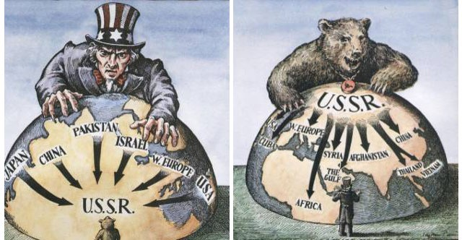
Containment
To halt the spread of communism to Western Europe from the Soviet-controlled nations of Eastern Europe, the United States formed a military and political alliance called North Atlantic Treaty Organization (NATO). NATO combined many of the noncommunist nations in Europe, including former wartime allies Britain and France. In response, the Soviet Union created the Warsaw Pact, an alliance of the communist nations it controlled in Eastern Europe. Convinced the Soviets were attempting to establish a sphere of influence throughout the world, the United States viewed these actions as a direct threat to American security. Americans determination to stop the spread of communism is known as the policy of containment and was the basis for many U.S. foreign policy decisions during the Cold War.
The Marshall Plan
The European Recovery Program, better known as the Marshall Plan for Secretary of State George Marshall, was America’s main program for rebuilding Western Europe and opposing communism after World War II. The plan was put into action in July 1947 and operated for four years. During that time, the United States spent $13 billion on economic and technical assistance for the war-torn democratic European countries that had been nearly destroyed during World War II. The Marshall Plan offered the same aid to the Soviet Union and its allies if they would make political reforms and accept certain outside controls; however, the Soviets rejected this proposal.
Document Analysis 2
The Truman Doctrine Political Cartoon
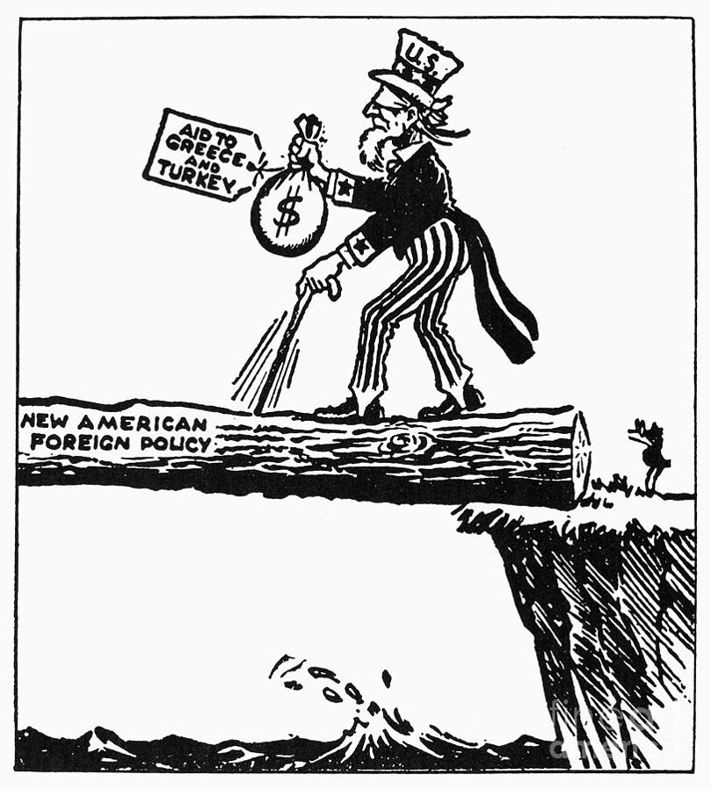
The Truman Doctrine
In 1947, President Harry S. Truman proclaimed the Truman Doctrine. It stated the United States would supply any nation with economic and military aid to prevent its falling under the Soviet sphere of influence. Truman called upon the United States to “support free peoples who are resisting attempted subjugation by armed minorities or by outside pressures.” Although Truman never referred directly to the USSR, anyone who heard the declaration, including the Soviet leaders, knew the Soviets were the “outside pressures” Truman talked about.
The Korean War
Korea was among the countries liberated from the Japanese during World War II. Since both the U.S. and the Soviets played a role in its liberation, the nation was divided along the 38th parallel (line of latitude that runs through Korea). The northern half of the country established a communist government while the southern half put in place a pro-US democracy. In June 1950, the Korean War began when North Korean forces crossed the 38th parallel. The United Nations elected to come to South Korea's aid and President Truman chose General Douglas MacArthur, the man who had liberated the Philippines and oversaw the establishment of a democracy in Japan after WWII, to lead the U.N. forces. Technically, the conflict was never a declared war, but rather a U.N. police action. MacArthur's forces pushed their enemy back across the 38th parallel. Continuing to advance north, the U.N. forces moved ever closer to the Chinese border. Concerned that U.S.-led forces were so close and wanting to maintain a communist regime in North Korea, the Chinese sent troops across the Yalu River to aid the North Koreans. A stalemate soon developed. To make matters more complicated, Truman fired MacArthur after the general criticized the president's handling of the war. After two more years of fighting, both sides signed a truce in 1953. The agreement left the country divided at almost the same point as when the conflict started.
b. Connect major domestic issues to their social effects including the G.I. Bill, Truman’s integration policies, McCarthyism, the National Interstate and Defense Highways Act, and Brown v. Board of Education.
G.I. Bill
The G.I. Bill of Rights was passed by Congress to protect and reward returning servicemen. The provisions included giving low interest loans for homes and starting new businesses to former soldiers. Financial grants were also given to the returning soldiers who wanted to attend college. The stimulus of money into housing caused a housing boom characterized by the development of the first suburban housing developments, such as Levittown, New York. The financial investment in returning soldiers stemmed a potential post-war unemployment crisis. Instead, consumer spending expanded as new furniture, appliances, and other household goods were needed. Increased consumer demand became the driving force in the post-war economy and the G.I. Bill helped to foster the surge.
Truman’s Integration Policies
Another important domestic issue that had a tremendous social impact in the late 1940s and 1950s was segregation. In July 1948, President Harry Truman signed an executive order ending the segregation of the armed forces. Prior to that time period, Black and White soldiers served in separate units. Integration of the Black units with White units did not fully take place until the Korean War in the 1950s. In general, there were three reasons why integration took place. First, there was a growing recognition that segregation undercut the United States' moral stature during the Cold War. Second, there was a need to reduce racial tension within the military. And third, there were significant manpower needs produced by the Korean War. Later studies commissioned by the military found that both Blacks and Whites benefitted from integration. Significantly, integration helped to break down stereotypes so that, as the Civil Rights Movement intensified in the mid-1950s, there was a broad spectrum of Americans who had developed relationships with other races.
Document Analysis 3
This, ladies and gentlemen, gives you somewhat of a picture of the type of individuals who have been helping to shape our foreign policy. In my opinion the State Department, which is one of the most important government departments, is thoroughly infested with Communist.
I have in my hand 57 cases of individuals who would appear to be either card carrying members or certainly loyal to the Communist Party, but who nevertheless are still helping to shape our foreign policy.
One thing to remember in discussion the Communists in our government is that we are not dealing with spies who get 30 pieces of silver for stealing the blueprints of a new weapon. We are dealing with a far more sinister type of activity because it permits the enemy to guide and shape our policy…
Source: Senator Joseph R. McCarthy, Speech, February 9, 1950, Wheeling, West Virginia, in Congressional Record, 81st Congress, 2nd Session.
McCarthyism
One of the most interesting characters to arise as a result of the second Red Scare was Wisconsin Senator, Joseph McCarthy. McCarthy was convinced that Communists had infiltrated high levels of government and the U.S. military. He even accused former army chief of staff and secretary of state, George Marshall. At first, Communist aggression in Korea served to help McCarthy and his ideas gain popularity. Eventually, however, McCarthy had to defend his views in a series of televised hearings. By the time the hearings ended in June 1954, most US citizens viewed McCarthy as paranoid at best and downright crazy at worst. "McCarthyism" (the ideas and fears of communism voiced by McCarthy and his supporters) began to collapse, and the irrational fear that "Communists are everywhere" ultimately subsided.
The National Interstate and Defense Highway Act
President Eisenhower also wanted to further secure the United States from any future attacks. A prime example of how this domestic issue had a social effect was the government-sponsored creation of infrastructure through the National Interstate and Defense Highways Act, which was passed in 1956. The original purpose of the Act, as envisioned by President Eisenhower, was to create a system of highways for strategic transportation of troops and supplies. As the United States' population grew, the old two lane system of roads connecting communities was proving inadequate. New, wider, more direct routes built across the United States served to link population centers across the nation. As a result, the Interstate Highway Act not only shored up the nation's ability to move military defenses more efficiently, but it also forever changed population patterns and allowed for the growth of suburbia.
Brown v. Board of Education
The evolution of integration was boosted by the Brown v. Board of Education decision. The Supreme Court had ruled in the 1896 Plessy v. Ferguson decision that "separate but equal" was the law of the land concerning segregation. In practice this meant that many states had created two systems of public accommodations - one White only, one Black only. In 1951, a Topeka, Kansas parent challenged segregation by suing his local school board. His daughter had to attend the Black elementary school that required her to walk a mile, even though the closest elementary school (White only) was only seven blocks away. The NAACP took on the case but lost on the Plessy precedent. The case was appealed to the Supreme Court. In 1954, the Supreme Court unanimously ruled, "...in the field of public education, the doctrine of 'separate but equal' has no place. Separate educational facilities are inherently unequal."
The Supreme Court ordered that public education be de-segregated, but no timeline was issued and school systems were slow to comply. In response to the Brown decision, Southern states organized the "Massive Resistance" movement, which shut down state education systems rather than integrate the schools. A notable example of this type of action occurred in Little Rock, Arkansas in 1957 when Governor Orval Faubus attempted to use the National Guard to block integration of Central High School. President Eisenhower responded by federalizing the Guard and moving units of the 101st Airborne into Little Rock to enforce the law. Faubus countered by closing Little Rock's schools for a year.

c. Examine the influence of Sputnik on U.S. technological innovations and education.
Document Analysis 4
Sputnik came as a surprise to most Americans - but it should not have, observes John Logsdon, Director, of the Space Policy Institute, Elliott School of International Affairs at George Washington University in Washington, D.C. “Our movies and television programs in the fifties were full of the idea of going into space. What came as a surprise was that it was the Soviet Union that launched the first satellite. It is hard to recall the atmosphere of the time. Fallout shelters, rabid anti- Communism, a sense of imminent danger from without and within,” Logsdon said. With the launch of the Soviet satellite, Logsdon said, the reaction was more fear than surprise, because it showed clearly that the United States was no longer safe behind its ocean barriers. “The claim that who controlled space would control the Earth seemed plausible, and the Soviet Union had taken the first step towards that control,” he said.
Source: Leonard David. (October 2002). Sputnik 1: The Satellite That Started It All. Space.com.
Sputnik
The US and the USSR distrusted one another even before World War II. The atomic bomb, and later the hydrogen bomb, only intensified the friction between the two nations. Each felt compelled to keep up with the other's nuclear capabilities. In 1957, the Soviets launched Sputnik, the first artificial satellite to orbit the earth. Sputnik revealed the superiority in Soviet technology and greatly concerned the US. Realizing that this same technology could be used to launch nuclear missiles, the United States eagerly entered the space race (competition with the Soviet Union to gain the upper-hand in space travel and technology). In 1958, Congress passed the National Defense Education Act. This law provided aid for education and was geared towards boosting the study of science, math, and foreign languages. It was intended to propel the US in front of the Soviet Union in technological innovations such as the space race and in nuclear technology. In 1961, the Soviet Union once again demonstrated that they were ahead in the space race when they successfully launched the first manned space flight. Yuri Gagarin successfully orbited the earth on board a Soviet spacecraft. Not to be outdone by the Soviets, President John F. Kennedy issued a challenge to the US to put a man on the moon before the end of the decade. Less than a year later, NASA (the National Aeronautics and Space Agency) successfully launched a spacecraft carrying astronaut, John Glenn into orbit. Seven and a half years later, on July 20, 1969, Neil Armstrong answered President Kennedy's challenge by becoming the first human being to walk on the moon

