American Imperialism 8.1

SSUSH14 Explain America’s evolving relationship with the world at the turn of the twentieth century.
a. Describe how the Spanish-American War and territorial expansion led to the debate over American imperialism.
Document 1
American Imperialism
Toward the end of the nineteenth century, a growing number of citizens believed that the United States needed to look beyond its own borders and acquire more territory, such an attitude is known as imperialism. Many business leaders and politicians believed that US expansion was important because it would provide the country with more economic markets and greater potential for economic growth. Others backed imperialism because they felt that the United States needed to expand (or at least be capable of expansion) in order to maintain its national security. Still, others believed it was part of the country's destiny and crucial to maintaining a nationalist spirit (feeling of national
pride).
Initially, most expansionists turned their attention towards the Pacific. Both political leaders and businessmen in the US wanted to trade with China and other nations in Southeast Asia. They saw the Pacific Ocean as the pathway to these markets. To promote unthreatened access to Southeast Asia, Secretary of State William Seward negotiated the purchase of Alaska from Russia in 1867. Roughly thirty years later, the US annexed Hawaii as well. Not only was Hawaii home to Pearl Harbor (a potentially important naval base), it was also economically important. By acquiring Alaska and Hawaii, the US believed it helped open trade routes across the Pacific while, at the same time, gaining valuable territory.
Debate Over Territorial Expansion
Yet, while more and more US citizens were advocating imperialism, the anti-imperialist preached isolationism. They believed that it was not in the best interest of the United States to acquire and exercise control over foreign territories. They felt that such acquisitions would inevitably pull the US into foreign conflicts. While some pointed to domestic concerns and believed that it was not economically nor politically wise to expand, others made the case that expansion contradicted the very principles of freedom and self-government on which the United States was founded.
Spanish-American War
In the late 1800s, the island of Cuba was still under Spanish rule. In 1895, the Cuban people rebelled, and Spain sent 150,000 troops to restore order. As part of their strategy, the Spanish relocated thousands of Cuban citizens to concentration camps. These camps had miserable conditions and many Cubans died. As pressure mounted for the US to intervene, competing newspapers printed stories about the Spanish abuses against the Cubans. Often exaggerated and untrue, these stories were meant to sell papers rather than accurately report the facts. They also served to ignite the emotions of the US public and contributed to calls for war with Spain. One of the many voices calling for war was that of Assistant Secretary of the Navy Theodore Roosevelt. When war finally came, Roosevelt resigned his position to become a Lt. Colonel and command a group of volunteers known as the Rough Riders.
Document 2
DESTRUCTION OF THE WAR SHIP MAINE WAS THE WORK OF
AN ENEMY
Assistant Secretary Roosevelt Convinced the Explosion of the War
Ship Was Not an Accident.
The Journal Offers $50,000 Reward for the Conviction of the
Criminals Who Sent 258 American
Sailors to Their Death.
Naval Officers All Agree That the Ship Was Destroyed on Purpose.
NAVAL OFFICERS THINK THE MAINE WAS DESTROYED BY A
SPANISH MINE.

Source: New York Journal and Advertiser: February 17, 1898
The Spanish-American War officially began as a result of what happened on February 15, 1898. A US battleship, the USS Maine, exploded while anchored in a Cuban harbor. Immediately, the newspapers blamed Spain and US citizens demanded war. Although it was later determined that the explosion was most likely an accident, Congress adopted a resolution declaring war on Spain in April 1898. Upon hearing of the declaration of war, US Commodore George Dewey set sail for another Spanish colony, the Philippines. Destroying the Spanish fleet there, Dewey quickly seized control of the Philippine Islands. Meanwhile, in Cuba, Roosevelt won praise for leading the Rough Riders in bold charges up Kettle and San Juan Hills. This became the most famous incident of the war and helped the United States achieve victory over the Spanish. In less than three months, the United States had defeated Spain in both Cuba and the Philippines. To people in the US it seemed like a relatively easy victory. John Hay, the future secretary of state and good friend of Theodore Roosevelt, captured what most felt regarding the entire conflict when he referred to the taking of the Philippines as "a splendid little war."
The Spanish-American War officially ended with the signing of the Treaty of Paris (1898). Attached to Congress' 1898 war resolution with Spain was the Teller Amendment, which promised that the United States would allow Cuba to be independent and not annex the territory. However, to protect US business interests, President William McKinley installed a US military government for three years to restore stability. In 1900, when the Cubans began drafting their own constitution, the United States continued to exercise its influence by insisting that the document include the Platt Amendment. This amendment put limits on what the Cuban government could do, gave the US two naval bases in Cuba, and allowed for US intervention in the region whenever the United States believed it was necessary. The Platt Amendment stayed in effect until the early 1930s. Meanwhile, Puerto Rico, Guam, and the Philippines became US territories.
b. Examine U.S. involvement in Latin America, as reflected by the Roosevelt Corollary to the Monroe Doctrine and the creation of the Panama Canal.
Creation of the Panama Canal
Following the assassination of President William McKinley in 1901, Theodore Roosevelt became the 26th president of the United States, in order to increase trade between the Atlantic and Pacific Oceans, Roosevelt envisioned a canal across the Isthmus of Panama. This canal would serve US military and economic interests by allowing ships to travel back and forth between US territories in the Pacific and Atlantic without having to go around South America. Unfortunately for the president, the Colombian government which controlled the territory refused to sell or lease the land necessary for the project. Then, in 1903, the Panamanian people revolted against the Colombians. Roosevelt responded by providing US naval support that helped the Panamanians win their independence. In return, the Panamanians allowed the US to lease the land needed for the canal. Construction got underway in 1905, and, in 1914, workers completed the Panama Canal. The US continued to control the canal until President Jimmy Carter signed a treaty in 1977 authorizing the transfer of the canal to the Panamanians. Panama finally took full control of the Panama Canal in December 1999.
Roosevelt Corollary to the Monroe Doctrine
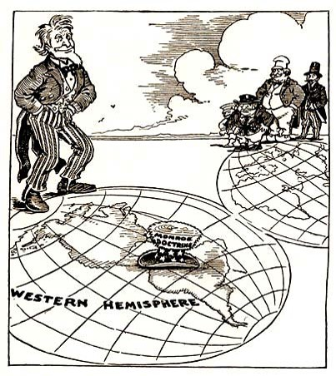
Document 3 Document 4
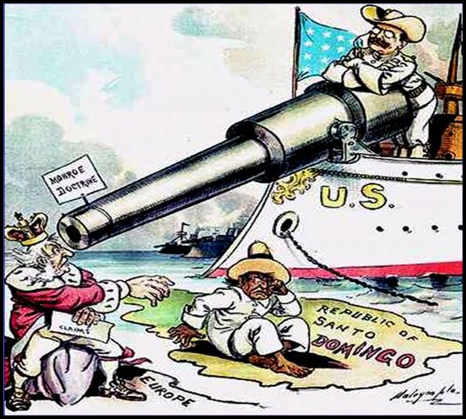
By the 1900s, the United States was becoming a major player in world affairs. In 1904, President Roosevelt issued Roosevelt's Corollary. It was a statement which expanded upon the Monroe Doctrine. Monroe had said that the US would not allow European powers to colonize newly independent nations in the Western Hemisphere, nor would the US interfere with such nations. Roosevelt modified this by saying that the US had the rig ht to intervene in the region if a nation had trouble paying its debts. Roosevelt wanted to make sure that imperialist nations did not use debt collection as an excuse to occupy territories in the Caribbean or Latin America. This doctrine came to be known as Roosevelt's "big stick diplomacy.” The name came from a West African proverb which said, "Speak softly and carry a big stick." It meant that the US did not intend to be a threatening presence in the Western Hemisphere, but neither would it hesitate to forcefully protect its own interests.

