Comic Book Covers of WWII
- Captain America Comics #1 March 1941
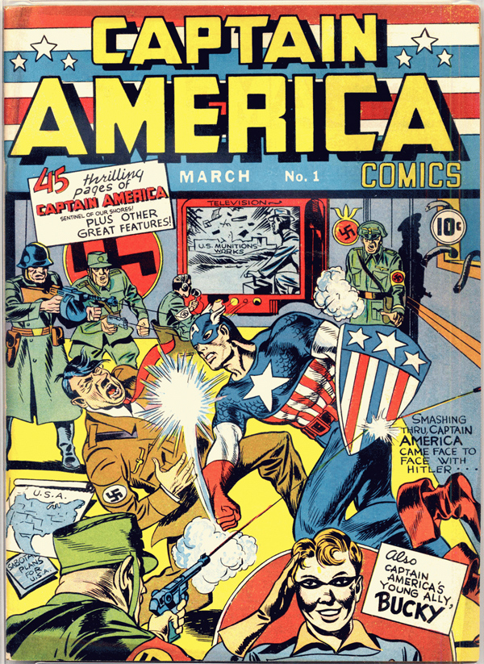
1. What symbols do you see in this picture what do they represent?
2. What was Hitler planning before Captain America showed up, how can you tell?
3. What is odd about what is happening in the picture based on the date of the comic? What
does that tell you about the way some Americans felt at this time?
- Captain America #13
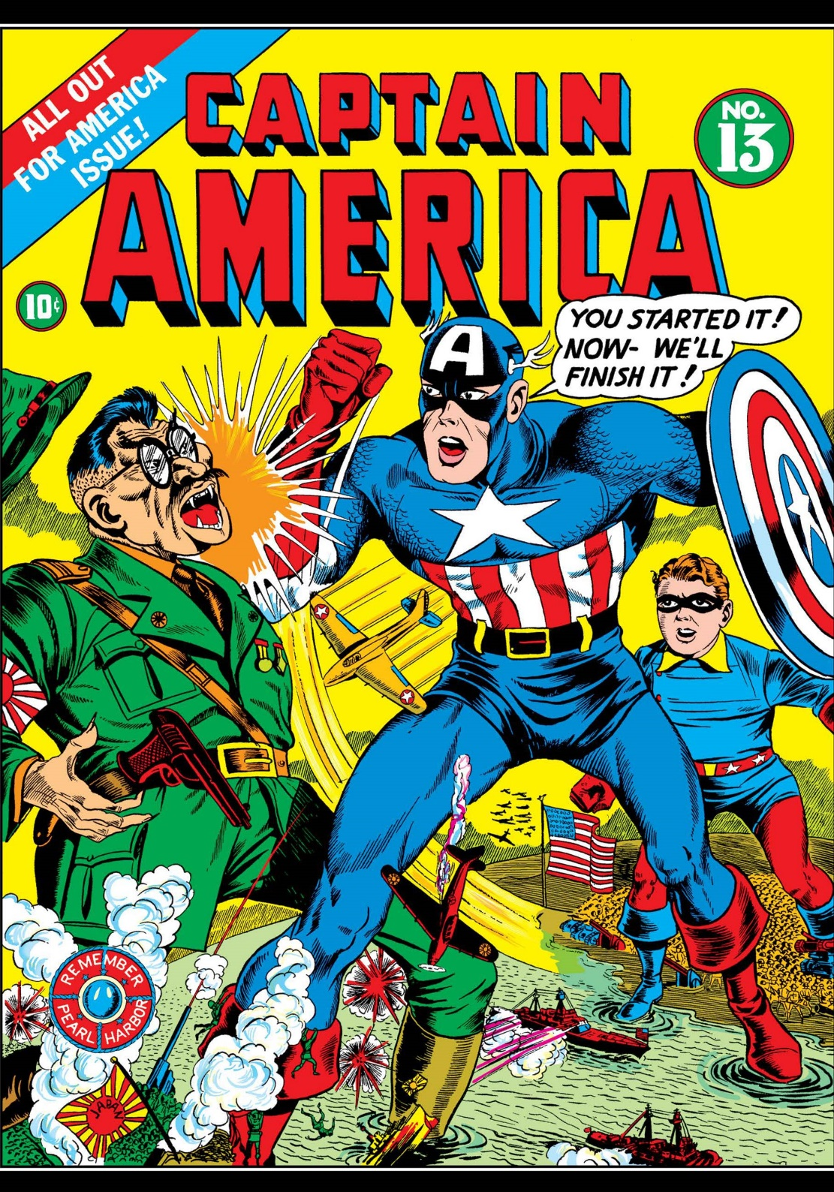
4. Who is Captain America punching in this photo?
5. What does Captain America mean by what he is saying?
6. How is the Japanese soldier drawn? Why is he drawn that way?
III Superman #29
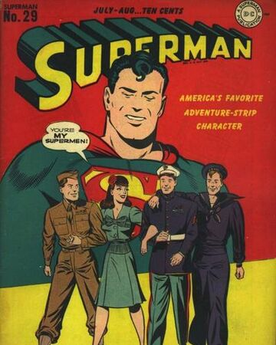
7. Who are the men pictured on this cover, what branches do they represent?
8. What is the message that this cover is trying to convey?
9. What is the purpose of the message? What is it trying to get young boys to do or believe?
Extended Writing:
10. On the back of this paper write a paragraph that answers the following question:
What can comic book covers tell us about the way people felt about World War II

