Roaring 1920's 9.1

SSUSH16 Investigate how political, economic, and cultural developments after WW I led to a shared national identity.
a. Explain how fears of rising communism and socialism in the United States led to the Red Scare and immigrant restriction.
Rise of Communism and Socialism
In 1917, Russia pulled out of World War I due to its own revolution at home. A party known as the Bolsheviks took over and installed a socialist government. A socialist government is one in which the state owns most of the property, regulates the economy, and runs most of the major industry. Individual freedoms are not nearly as important as the welfare of the state. The Bolsheviks modeled their ideas about government after the teachings of a man named Karl Marx. Marx believed that oppressed workers would eventually rise up and throw down capitalism (an economic system based on free markets and privately owned industry). He advocated communism (a system in which people in society cooperate and own property mutually, thereby making governments unnecessary). According to Marx, socialist governments were meant to provide order while societies made this transition from Capitalism to communism. Once they took over Russia, the Bolsheviks installed a government they believed would lead to communism.
Bolshevik leaders believed that, in order for their vision to become a reality, workers in other countries needed to rise up and establish socialist governments as well. This greatly alarmed people in the United States. Business leaders, government officials, and a growing number of private citizens feared that such a revolution might occur in the US. This led to a period known as the "Red Scare", in which many people became fearful of anyone who might be a communist or a threat to US freedom. When anarchists (those who want to bring down any form of government) attempted to assassinate Attorney General A. Mitchell Palmer and Standard Oil icon John D. Rockefeller, many associated the attacks with communism. In response, Palmer authorized the Palmer Raids, in which suspected communists and people perceived to be a threat, many of whom were immigrants who had committed no crimes, were arrested and jailed. More than 500 immigrants were deported back to their countries of birth as a result of Palmer's actions.
Document Analysis 1
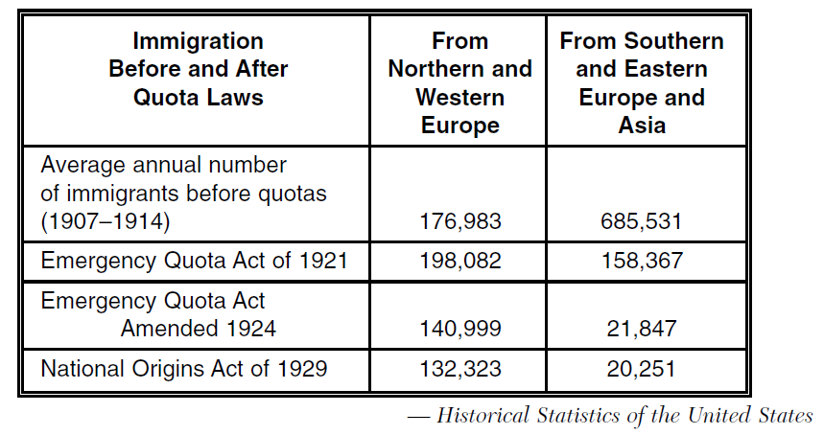
Immigrant Restriction
The Red Scare and suspicions about immigrants led to a new rise in nativism (opposition to immigration). As a result, citizens pressured the government to place restrictions on immigration. Congress passed a temporary limit to the number of immigrants beginning in 1929. Racist in nature, many of these laws were designed to allow more immigrants from Western Europe into the country than from Eastern Europe or the Far East. Because few laws addressed immigration from nations in the Western Hemisphere, a large number of Hispanic Catholic immigrants (both legal and illegal) increased drastically during this time period and made Latin Americans the fastest growing minority in the United States. Meanwhile, the Ku Klux Klan also saw resurgence due to its willingness to expand its attacks. No longer did it only go after African Americans; the Klan targeted Jews, Catholics, Communists, and foreign immigrants as well. By proclaiming their prejudice and opposition to such groups, the Ku Klux Klan grew to be a national, rather than just a southern, force of hatred.
b. Describe the effects of the Eighteenth and Nineteenth Amendments.
Eighteenth Amendment
Document Analysis 2
Causes of Prohibition (18th Amendment) | Effects of Prohibition (18th Amendment)
- Various religious groups thought drinking alcohol was sinful  - Reformers believed that the government should protect the public’s health.  - Reformers believed that alcohol led to crime, wife and child abuse, and accidents on the job  - During World War I, native born Americans developed a hostility to German-American brewers and toward other immigrant groups that used alcohol. | - Consumption of alcohol declined.  - Disrespect for the law developed.  - An increase in lawlessness, such as smuggling and bootlegging, was evident.  - Criminals found a new source of income.  - Organized crime grew.
Nineteenth Amendments
In 1917, America entered World War I, and women aided the war effort in various capacities that helped break down most of the remaining opposition to woman suffrage. By 1918, women had acquired equal suffrage with men in 15 states, and both the Democratic and Republican parties openly endorsed female enfranchisement (Voting rights). In 1920, the 19th Amendment, guaranteeing women the right to vote, is formally adopted into the U.S. Constitution by proclamation of Secretary of State Bainbridge Colby. The amendment was the culmination of more than 70 years of struggle by woman suffragists. Its two sections read simply: “The right of citizens of the United States to vote shall not be denied or abridged by the United States or by any State on account of sex” and “Congress shall have power to enforce this article by appropriate legislation.”
c. Examine how mass production and advertising led to increasing consumerism, including Henry Ford and the automobile.

Henry Ford and the Automobile, Mass Production, and Advertising
The 1920s was a time of increased consumer buying. People were purchasing new automobiles and household appliances through various means of financing. The new mode of individual transportation changed society by making the population more mobile and able to live greater distances from their jobs. Advertising of cars and new household appliances was largely through nationwide campaigns on the radio, in magazines, and at the movies. People began to see themselves as "needing" certain items of convenience rather than simply "wanting" them.
Henry Ford was the developer of the first mass produced automobile - the Model T. While the idea of mass production was not new, Ford used an improved continuous assembly line to quickly build automobiles. Ford constructed his manufacturing facilities so that all the elements of production (foundries, machine shops, assembly lines) were all in one location. He was also able to speed up production and drive down costs of automobiles by standardizing parts, focusing on specialization of labor, and through careful management. At its introduction in the market, Ford's Model T cost $950. Within ten years, the same model cost $280 due to improved poduction methods.
The automobile led to huge social changes in America. People began moving to the suburbs because of their widespread ownership of cars. There was also a new need for improved roads and highways. Travel was more independent and vacations for pleasure became popular. As a result new businesses were needed such as gas stations, motels, and roadside restaurants.
d. Describe the impact of radio and movies as a unifying force in the national culture.
Document Analysis 3
The only problem was that just as we were becoming stars, vaudeville (stage play) was dying. No one could pin the rap on us, though. Everybody believes it was the movies that killed vaudeville. That’s not true. Movies, vaudeville, burlesque, the local stock companies—all survived together.
Then radio came in. For the first time people didn’t have to leave their homes to be entertained. The performers came into their house. Gracie and I knew that vaudeville was finished when theaters began advertising that their shows would be halted for fifteen minutes so that the audience could listen to ‘Amos & Andy’. And when the ‘Amos & Andy’ program came on, the vaudeville would stop, they would bring a radio onstage, and the audience would sit there watching radio.
It’s impossible to explain the impact that radio had on the world to anyone who didn’t live through that time. Before radio, people had to wait for the newspaper to learn what was happening in the world. Before radio, the only way to see a performer was to see a performer. And maybe most important, before radio there was no such thing as a commercial.
Radio made everybody who owned one a theater manager. They could listen to whatever they wanted to
Source: George Burns, Gracie a Love Story, 1988
Impact of the Movies
Two developments that the most impact in media were the radio and movies. Long before television, radios became the first source of mass communication and entertainment available to people in their own homes. Radio united the nation and molded a national culture like never before as people across the country enjoyed the same shows and heard the same news reports. It also transformed politics by giving leaders direct access to larger numbers of people. During this same period, the movie industry boomed in the United States. First to silent pictures, then to movies with sound (called "talkies"), people flocked to be entertained by the big screen. The fashions and lifestyles portrayed in the movies helped define a national culture. People all over the nation wanted to wear the clothes they saw in the movies, drive the cars they saw on screen, and take part in the fads popularized by Hollywood. As a result of popular movies, movie stars became national icons. Both the radio and movies helped to unify the national culture through different forms of communication.
e. Describe the emergence of modern forms of cultural expression including the origins of jazz and the Harlem Renaissance.
The Emergence of Modern Forms of Cultural Expression
One form of cultural expression was the Harlem Renaissance. The Harlem Renaissance marked the first significant artistic movement coming out of Black culture. Centered in the Harlem borough of New York City, the movement produced notable works of literature, music, dance, and visual art. Writers included W.E.B. DuBois and Langston Hughes. Hughes' poetry used the rhythms of Black music, particularly blues and jazz. This allowed Hughes to experiment with a very rhythmic free verse. Harlem's Cotton Club was an important location, where White audiences were exposed to ideas of the Harlem Renaissance - including Jazz.
Performing arts expanded with the advent of radio and movies. As income rose during the period, families had more money available to spend on entertainment. Radio stations needed to fill airtime by broadcasting the latest music to listeners. Jazz was a genre that benefitted from this demand for music.
Another form of cultural expression was Jazz. Although Jazz was not born out of the Harlem Renaissance, it was the first true American music. The musical form was so influential that the era of the 1920s is often referred to as the Jazz Age. Born in the Deep South, Jazz was thought to have originated from the musical traditions brought by slaves from West Africa combined with western musical instruments and techniques. Jazz, as a musical style, is easy to recognize but hard to define. Jazz has elements of different genres of music but is most noted for its improvisations. By the 1920s, there were several different types of Jazz, including Dixieland that originated in New Orleans. Famous Jazz musicians included Louis Armstrong and Duke Ellington. Jazz also influenced composers such as Cole Porter and the Gershwin Brothers who composed Rhapsody in Blue and the Jazz opera Porgy and Bess.

