World War I 8.2

SSUSH15 Analyze the origins and impact of U.S. involvement in World War I.
a. Describe the movement from U.S. neutrality to engagement in World War I, including unrestricted submarine warfare and the Zimmerman Telegram.
U.S. Neutrality
At first, the United States did not get involved in World War I. In fact, in 1914, President Woodrow Wilson officially declared the United States neutral (not backing either side). Many in the United States believed in isolationism (the philosophy that the United States should stay out of international conflicts) and did not see a war in Europe as being of any concern to the US. Many citizens became peace activists during this period. Others supported a policy of "preparedness", which advocated neutrality while taking steps to prepare for war just in case it became necessary. US policy towards the war became the key issue in the 1916 election. Wilson narrowly won a second term running on the slogan, "He kept us out of war!"
Document Analysis 1
Property can be paid for; the lives of peaceful and innocent people cannot be. The present German submarine warfare against commerce is a warfare against mankind. The German policy has swept every restriction aside. Ships of every kind, whatever their flag, their character, their cargo, their destination, their errand, have been ruthlessly sent to the bottom of the ocean without warning. American ships have been sunk (The Lusitania), American lives taken.
I advise that the Congress declare the recent actions of the Imperial German Government to be, in fact, nothing less than war against the Government and people of the United States. Neutrality is no longer
Source: President Woodrow Wilson, in a speech before Congress, April 2, 1917.
Reasons for Entering World War I
Despite Wilson's original desire for neutrality, a number of factors eventually led to US involvement in the war. One of Germany's fiercest weapons in WWI was their dreaded U-boats. These were submarines that traveled under water and wreaked havoc in the Atlantic during the war. The Germans warned all nations that they would attack any ships entering or leaving British ports. President Wilson rejected the warning, arguing that no warring party could be allowed to disrupt neutral shipping on the high seas. In reality, however, the US was not entirely neutral. Unknown to passengers, the US had begun shipping military supplies to Great Britain aboard commercial cruise liners. One of these liners, the Lusitania, was torpedoed by a German U-boat in 1915. Twelve hundred people died in the attack, including 128 US citizens.
Unrestricted Submarine Warfare
People in the US were furious. A wave of anti-German feeling swept across the country. Not wanting to pull the United States into the war, Germany agreed not to attack anymore US passenger ships. However, in 1917, Germany resumed their attacks on merchant and commercial ships, moving the United States closer to war. The German's policy of attacking all ships was known as unrestricted submarine warfare. Although the Germans knew such a policy would encourage the US to enter the war against them, the fact that the Russians had dropped out of the fighting to deal with their own revolution led Germany to believe that it could rapidly defeat its remaining enemies before any US troops could reach Europe. They were wrong.
The Zimmerman Telegram
It was also in 1917 that the US intercepted the Zimmerman telegram. Arthur Zimmerman, the German Foreign Minister, sent a telegram to the German embassy in Mexico. In his telegram, Zimmerman told embassy officials to ask Mexico to attack the US if it declared war on Germany. In return, Germany promised to help Mexico win back land the US had acquired as a result of the Mexican-American War. As you might imagine, news of this communication did not go over well in the United States. Anti-German sentiment increased even more, and President Wilson broke off diplomatic relations with Germany. Likewise, more sinking of US ships meant that the United States could no longer stay neutral. In March 1917, Wilson made an idealistic case for war and proclaimed
that the world "must be made safe for democracy." Wilson wanted the US public to see the war as a battle between good and evil; he wanted the people to view it as a fight between democracy and tyranny. His appeals were well received. Congress passed a war resolution soon afterwards, and in April 1917, the United States officially entered World War I.
b. Explain the domestic impact of World War I, including the origins of the Great Migration, the Espionage Act, and socialist Eugene Debs.
Document Analysis 2
One-Way Ticket
I pick up my life and take it with me and I put it down in Chicago, Detroit, Buffalo,
Scranton, Any place that is North and East- and not Dixie.
I pick up my life and take it on the train to Los Angeles, Bakersfield, Seattle, Oakland,
Salt Lake, any place that is North and West-and not South.
I am fed up with Jim Crow Laws, people who are cruel and afraid.
By: Langston Hughes
Domestic Impact of World War I
The Great Migration
There was also an important social impact of the war. The nation's enlarged army needed supplies. The demand for products (weapons, supplies, uniforms, equipment, etc.), combined with the fact that many young men left their jobs to fight in the war meant that there were more jobs in northern cities where most of the nation's factories existed. As a result, many African Americans began leaving the South in growing numbers to pursue better economic opportunities and in hopes of escaping southern racism. This mass movement of African Americans from the predominantly rural South to northern cities continued for several decades. It became known as the Great Migration. (Migration is when people move from one part of a country to another).
The Espionage and Sedition Acts
Although the fighting took place overseas, World War I had a huge effect on life in the US. For starters, the war in Europe meant an increased role for government in the United States. Many (but not all) progressives embraced the war because it finally gave government the support and justification it needed to seize more control. The federal government also passed a number of laws limiting freedom. In the name of protecting national security, Congress passed the Espionage and Sedition Acts. These acts made it illegal to interfere with the draft, obstruct the sale of Liberty Bonds, or make statements considered disloyal to, or critical of, the government, the Constitution, or the US military. Socialist leader, Eugene Debs, was actually sentenced to ten years in prison under these laws for criticizing the US government.
c. Explain Wilson’s Fourteen Points and the debate over U.S. entry into the League of Nations.
Wilson’s Fourteen Points
In January 1918, President Wilson spoke to Congress about the war aims of the nation. His plan ultimately became known as the Fourteen Points and was designed to create a lasting peace in the world. Once negotiations for the Treaty of Versailles were completed in June 1919, the United States was divided over whether to join the League of Nations –( Nations joining together to keep the peace).
Wilson’s Fourteen Points became a guide for the negotiations at Versailles to secure peace after World War I. Some of Wilson's suggestions were accepted, some modified, and some rejected by the countries represented at the peace conference. The Fourteen Points included the following:
- Open diplomacy (no more secret treaties
- Freedom of the seas
- End international trade barriers
- Reduce armaments
- Impartial dealing with colonies and their natives
- Create an international organization, the League of Nations, to help keep the peace (THIS WAS POINT 14 of the plan)
Document Analysis 3
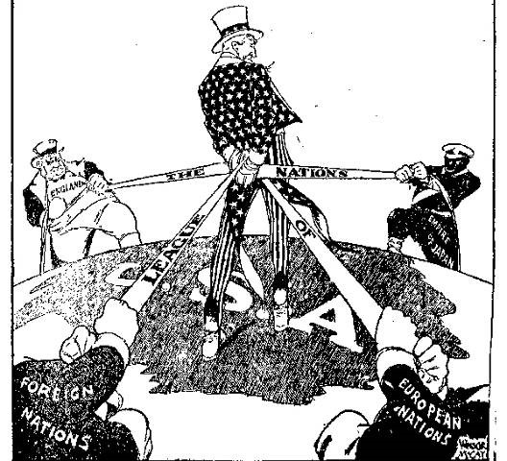
Wilson’s Fourteen Points (Continued)
During the postwar treaty negotiations, Wilson worked hard to get as many of his Fourteen Points as possible included in the treaty. The Fourteenth Point, which proposed a League of Nations, was one that President Wilson was particularly committed to securing for world peace. After much negotiation, the League of Nations was included in the final provisions of the Treaty of Versailles. The treaty drafted at Versailles had to be ratified by the United States Senate as the final step for implementation in the United States.
Although Wilson believed strongly in the League of Nations, there was significant opposition to the concept among many Americans. Public opposition to the League of Nations ultimately led the Senate to vote against ratification of the treaty. Isolationists in the Senate believed that by joining the League of Nations, the United States would be obligated to get involved in future European conflicts.
One of the most vocal critics of the League was Senator Henry Cabot Lodge. Lodge was a Republican and Wilson was a Democrat. They held different ideas about the role the United States should take in world affairs. Lodge was a powerful and respected Senator who served as his party’s majority leader and was on the Senate Foreign Relations Committee. Lodge, and others from his party, believed that he should have been involved in the treaty’s negotiations.

